Fact Sheet
What: Ramos Park Playground and Walkways Closure
Where: See map below for closed area
Why: Tree roots have damaged the existing walkways. City crew will remove and replace the concrete to improve safety and accessibility walkways with new concrete in the area.
When: Thursday, April 9 - Monday, April 13, 2026
Contact: For more information, please contact the Parks at 650-496-6962.
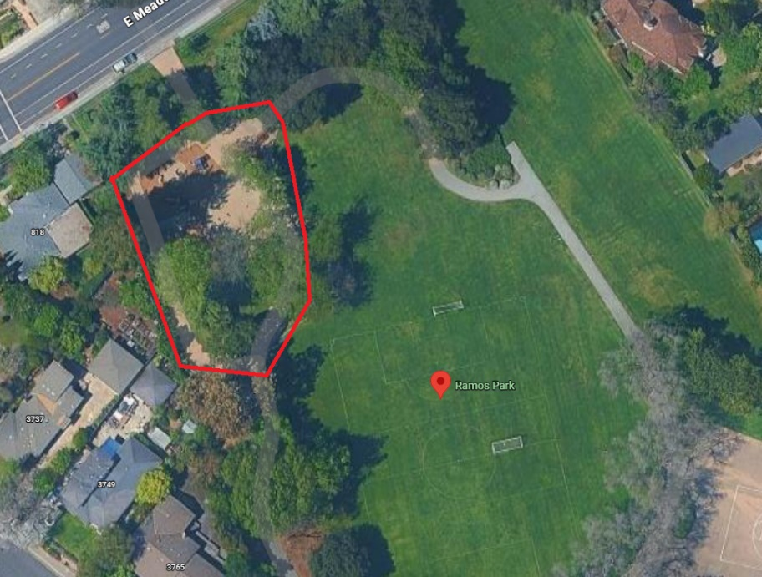
Posted: March 31, 2026

